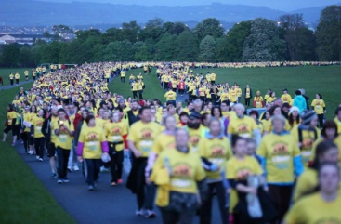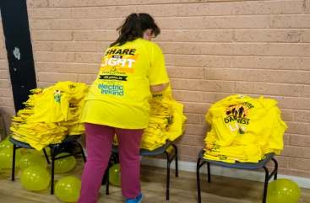

**Wexford**

Darkness Into Light Enniscorthy

* [**REGISTER TODAY**](https://em.eventmaster.ie/client/order_step1.html?eventId=817&showHeader=true)

Walk by the beautiful River Slaney and soak up the atmosphere of this symbolic event in **Enniscorthy** as we walk into the light in the sunny south east. As we say every year when **Darkness Into Light** rolls around... remember to dress warmly and meet us there before 4.00am in the morning!

For more information about **Darkness Into Light Enniscorthy**, please contact **Marie Peelo** at [**dilmariepeelo@gmail.com**](mailto:dilmariepeelo@gmail.com)**,**phone **01 6219374**or, **alternatively**, visit their [**Facebook page.**](https://www.facebook.com/Darkness-Into-Light-Enniscorthy-462340380534649/?fref=ts)

**Day:** Saturday

**Date:** May 7th

**Distance:** 5km circuit

**Time:** 4.15am

**Starts/finishes** at Shamrocks GAA club

**Important Information:**

1. You **MUST** print your receipt and bring it on the morning to pick up your t-shirt.

2. Late registration on the morning does not guarantee a t-shirt.

3. Please arrive by 4am. Please also allow time for parking.

4. Bring your torch.

5. Please respect traffic wardens and follow any instructions on arrival.

6. Please place any litter in bins provided.

7. There will be no storage for personal items during event, so please come ready to walk/run.